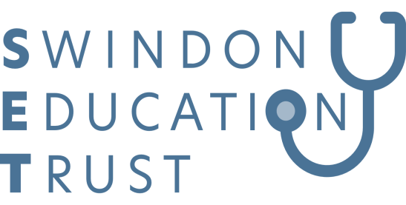
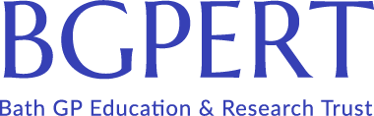
Perils of Social Media
by Abigail Moore- BMA Regional Co-ordinator, Hazel Brittan BMA Local Organiser.
In conjunction with BGPERT and the BMA
Thursday 27th May, 7.30pm-8.30pm
BGPERT Webinar via Zoom

This session is free to attend for all members of SET & BGPERT and GPs, Nurses and Clinical Pharmacists within BSW
To reserve a place please email kim.taylor18@nhs.net
The link to join the meeting will be sent to those registered the day before the meeting

Learning Objective:
The benefits of using social media are clear, however it's also important to be aware of the risks. The BMA south west team will discuss social media, ethics and professionalism for doctors

This meeting has been organised by BGPERT & SET
BGPERT have accredited this meeting. For more information about BGPERT including additional details about meetings visit our website
This meeting has been funded by the BMA & BSW Training Hub

