Are you a GP or healthcare professional who wants to thrive at work, rather than just survive?
“It was really thought provoking and has given me lots of ideas about how I can look at things differently at work” GP 2020

How to be Happy at Work

A masterclass for doctors and other busy healthcare professionals who want to love what they do again.

(Organisation)

(Time and link)

Do you wish you could enjoy your work like you used to rather than just struggling to make it to the end of the day?
We believe that if you’re happy at work, you’ll simply do a better job so in this masterclass, we will introduce you to some simple yet powerful tools that will help you do just that.
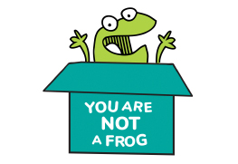
We’ll think about the evidence about why it’s more important to ‘work happier’ than to ‘work harder’ and explore the happiness traps we can all fall into.
Come to our masterclass to find out how to develop your strengths and skills, find the right opportunities and craft your career to do more of what you love – without leaving your current job.
Run by Dr Rachel Morris, GP, Coach, host of the You Are Not A Frog podcast and creator of the Shapes Toolkit. www.shapestoolkit.com

Find out how to work happier, not harder

